“Video Recuts and the Remix Revolution:
Whose Rights are Being Infringed?”
The Development of an Online
Remix Community known as Total Recut.
Owen Gallagher, BDes(Hons)

DES811M3

School of Creative Arts,
Faculty of Arts
University of Ulster at Magee

spiritdesign@eircom.net

Abstract

Video recuts – remixed audio-visual content from different sources – are a new art-form enabled by the convergence of emerging technologies. As we illustrate, video recuts breathe new life into stale works and encourage users to become both consumers and producers at once. Although video recuts offer the potential of untapped talent, creativity and entertainment, their mainstream development is stifled by overzealous copyright owners who are over-protective of their work. One of the reasons for this is the inadequacy of traditional copyright law to protect digital content in an online setting. Our remedy is a web community for video recuts and remix culture entitled Total Recut. Through a combination of video content, materials, tools and education, Total Recut provides fans and creators of video recuts with the opportunity to either consume or produce content in a shared online environment. Copyright owners may make their work available through the site as materials for others to remix, thus benefiting from increased exposure. Total Recut is one of the first to occupy the emerging online space for watching and creating video recuts.

1 Introduction

An age-old friction has escalated in recent times between copyright owners and those who wish to use parts of copyrighted material in new works. This concentrated friction is occurring as a result of the digitization and distribution of content on the Internet. Copyright owners, of movies and music in particular, are attempting to exercise unreasonable control over their content with a view to preventing piracy and subsequent loss of revenue. Unfortunately, this over-protection infringes on the basic human right to freedom of expression. Those who are not stealing from copyright owners, but merely exercising their rights to fair use of cultural works are being caught in the crossfire.

1.1 Video Recuts

Advances in technology now place the tools of production and distribution within the grasp of anyone with a computer and an Internet connection. As a result of this, new forms of creativity are emerging. People are no longer satisfied to passively consume content and have now evolved into ‘participatory consumers.’ Existing content is being sampled and remixed at every level to create new forms of cultural work. The most recent form to emerge from this remix culture is known as the ‘video recut.’ A recut is when a user samples audio-visual content from different sources and remixes it into a new creative work.

1.2 Total Recut

A website, totalrecut.com, has been developed to encourage remix creativity. Total Recut provides online resources for fans and creators of video recuts, remixes and mash-ups. Users may collect and watch video recuts, learn how to remix media, enter contests and connect to a thriving remix community by registering as a member of Total Recut. It is the aim of this project to encourage and promote creativity that builds on the work of the past and to protect the basic human right to freedom of expression in an increasingly restrictive online environment.

1.3 Copyright

Copyright exists to promote progress and the production of new creative works by offering authors a financial incentive for a limited time. Large media companies behave as if copyright exists to protect their profit margins indefinitely. Such companies have always resisted new technologies that threaten their existing business models. Today, they are actively attempting to restrict our access to cultural works in order to protect their profits.

“Enriching authors is not the primary goal of copyright law. The primary goal is to foster the creation of new works that will one day enter the public domain where they can be freely used to enrich everyone’s lives.”
1 of 9
1.4 Digital Rights Management

Large media companies have successfully lobbied for copyright extensions and for digital rights management technologies to be built into digital files, software and hardware. The only group that stands to benefit from these restrictions are media companies that own copyrights to a large number of works, for which they have already been fairly compensated in the past. Unfortunately, it is the average user who suffers most. Digital locks are being placed on our content. We are being cheated out of the ability to build upon works that should be in the Public Domain. We are being frivolously threatened with litigation for exercising our rights to freedom of expression. The market for innovation has chilled as people fear such litigation.

“We should regard those things that block participation – whether commercial or governmental –
as important obstacles to route around if we are going to democratise…any aspect of our culture.”

1.5 Remix Revolution

Copyright owners are concerned that they will lose out on compensation for their work as a result of unauthorised online distribution. Millions of people share digital files through the web without permission from the copyright owners. More recently, people have been uploading copyrighted material in its entirety to video sharing sites where they can be watched on demand by anyone. Both of these examples are clearly infringements of copyright in its current form, as they could adversely affect the ability of a copyright owner to be fairly compensated for their work.

Millions of other people are sampling from copyrighted material and remixing it with their own work to create something new. This is clearly not an infringement of copyright, as long as it is for non-commercial purposes. This type of creative activity does not affect a copyright owner’s ability to be fairly compensated. If anything, it acts as a form of free promotion, spreading their work to a wider audience.

“Technology has redefined how we use media. It has changed our expectations of how we interpret, interact with, and give back to the world at large. Today’s users expect their online activities to be steeped in collaboration, interaction, and expressiveness.”

1.6 Intellectual Property Debate

Copyright owners want to protect their potential to be fairly compensated for their work. Remix artists want to protect their right to freedom of expression and fair use. The argument is about balance, but it is an arbitrary balance, subject to change. At present, there is an imbalance in copyright law in favour of copyright owners. They are no longer merely seeking fair compensation for their work; they also want complete monopoly control over how it is used. Copyright law needs to be updated for the distribution of digital content online.

Total Recut attempts to bring copyright owners and remix artists together. Copyright owners can make their work available for remix artists to sample. Both groups can showcase their work and raise their public profiles. Total Recut aims to help bring balance to the Intellectual Property debate and encourage high quality remix creativity to exist in harmony with original content.

2 of 9
2 Literature Review

“A technology has given us a new freedom. Slowly, some begin to understand that this freedom need not mean anarchy. We can carry a free culture into the 21st Century, without artists losing and without the potential of digital technology being destroyed.”

2.1 Key Practitioners – Remix Culture Theorists


The Remix Revolution has been most eloquently described by JD Lasica of San Francisco, California. Lasica is one of the world's leading authorities on citizens' media and the revolution in user generated content. Lasica believes that ‘grassroots’ creativity will not allow large media companies to wield monopoly control over creative content. He also believes that if these goliaths of industry continue to place unwarranted restrictions on our access to content, more and more people will turn to ‘Darknets’ or underground filesharing networks where content is freely available to download illegally.

Fig.1 J.D.Lasica

Professor Lawrence Lessig has carried the flag for remix culture in the Intellectual Property debate for over ten years. He is the author of Free Culture (2004), The Future of Ideas (2001), Code and Other Laws of Cyberspace (1999) and Code 2.0 (2006). He was one of the founders of Creative Commons, an organisation that aims to offer a practical alternative to copyright. Artists may apply a Creative Commons licence to their work online, which gives automatic permission for others to use it, as specified by the author.
Fig.2 Lawrence Lessig

Henry Jenkins, a well-respected professor at MIT, has written extensively about convergence culture and Intellectual Property issues. He believes that fans play a hugely important and underestimated role in both the film and music industries. He feels that it can only be of benefit for copyright holders to allow fans to create unauthorised ‘fan art’, including video recuts, as it increases fan loyalty while simultaneously raising the profile of the original material being remixed.
Fig.3 Henry Jenkins

Professor Kembrew McLeod is well known for being a vocal activist and media prankster highlighting issues relating to the copyright wars. McLeod has written journal articles on copyright and music, and has published two books on the subject: Owning Culture: Authorship, Ownership and Intellectual Property Law (Lang, 2001) and Freedom of Expression®: Overzealous Copyright Bozos and Other Enemies of Creativity (Doubleday, 2005.)
Fig.4 Kembrew McLeod

2.2 Key Practitioners – Remix Artists

Several remix artists have received acclaim for their work since recuts began to take off in late 2005. Antonio Da Silva, a.k.a. AMDS Films, is a 31 year old Parisian film-maker who has made a name for himself by creating fan videos using footage from his favourite movies. His most successful work includes Terminator vs Robocop and Stallone vs Schwarzenegger.* His videos have been watched over 20 million times worldwide and as a result of this exposure, he has received offers from several Hollywood studios to work with them on new projects and won an award at the 2007 Romans Festival of Internet Creativity.
Fig.5 Antonio Da Silva
3 of 9
Mike Dow and Ari Esiner a.k.a. Smacky Productions, are responsible for some of the most well known video recuts on the web, including ‘Must Love Jaws’, ‘10 Things I Hate about Commandments’ and ‘Glen & Gary & Glen & Ross.’ Their video recut work has been featured in Rolling Stone and Time Magazine.

Robert Blankenheim a.k.a. Derek Johnson, created a fictional movie trailer for Titanic 2: The Surface, using footage from a variety of Leonardo di Caprio movies to weave together an elaborate story of cryogenic re-animation and time travel. Robert is 25 years of age, residing in Los Angeles, California and is currently working on other projects.

2.3 Competition

Most of the established video sharing networks including YouTube, iFilm, Daily-Motion and Google Video host video recuts. iFilm has a category for video mash-ups, but it is quite limited in terms of both quality and quantity. A student run blog called The Trailer Mash collects movie trailer recuts from around the web but neglects the other subgenres. Mashup-Charts collects music video recuts and presents them in a Top 10 format. A number of other new websites, mostly aimed specifically at movie trailer recuts, have also begun to spring up in recent months. Video recuts have huge potential for becoming viral hits. The Top 5 video recuts hosted on YouTube have been watched over 15 million times collectively, with the top 2 boasting an impressive viewership of over 4.5 million each. These figures are for YouTube alone, not including the dozens of other video sharing sites and bebo, myspace and facebook profile pages where these videos are also hosted.

3 Video Recuts

Today, film fans are no longer content to merely sit and watch a movie, they want to interact with it. When downloaded as a digital file from the internet, video becomes malleable, editable, remixable. Users can play with this material and produce all manner of creative content. This gives the user control over how they consume their media; a complete revolution from being spoon-fed by media companies in the 20th Century. Remixed video is an evolution from traditional film-making. It may be described as ‘Interactive Film’, as it encourages user interaction rather than mere passive consumption.
Total Recut has been brought into existence to establish a community of creators and fans of video recuts. The idea is to provide an on demand gallery of high quality video recuts, where remix artists can showcase their work and fans can watch, rate, share and comment on them. In addition, Total Recut aims to raise the quality level of work being produced by providing educational tools in the form of tutorials and reference material; to inspire, motivate and reward the production of new work by hosting contests; to provide raw materials in the form of Public Domain and Creative Commons licensed work for users to use in their own video recuts.

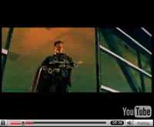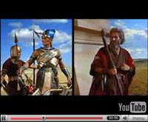

Fig. 8
10 Things I Hate
About Commandments
Hits: 1,700,000
Rating: 4/5
Favourited: 921 times
Smacky Productions
Fig. 6
Terminator vs Robocop
Hits: 230,000
Rating: 4/5
Favourited: 830 times
AMDS Films
Fig. 7
Bush Bloody Sunday
Hits: 663,797
Rating: 4/5
Favourited: 4626 times
DJ RX
Fig. 9
Titanic 2: The Surface
Hits: 5,670,746
Rating: 4/5
Favourited: 14,122 times
Robert Blankenheim

4 of 9
3.1 Sub Genres of Video Recuts

Eight sub-genres of video recuts have been identified: Movie Trailers, Political, Machinima, Advertising, Educational, Animation Lip Syncs, Music Videos and Fan Films.

    - Movie Trailer recuts
The most popular subgenre at present, based on the quantity of work available online, is the movie trailer recut. These clips are created by re-editing a well known film in the form of a movie trailer to portray it in a different light than it was originally intended, e.g. the film Dirty Dancing was recut to appear as a psychotic stalker thriller.
Fig. 10 ‘Dirty Dancing Recut’ Hits: 8695 Fave: 31

3.1.2 Political recuts
Political recuts are when footage of well known political figures is remixed to poke fun at the politician or highlight an important political issue. There are numerous examples that remix footage of George Bush, notably, a clip of himself and Tony Blair performing the song ‘Endless Love.’

3.1.3 Machinima
Machinima is a thriving subgenre of video recut that uses 3D game engines to act out scenes, sometimes using original scripts, sometimes audio tracks from well known movies or TV shows. An example of this genre is an enactment of the courtroom scene from the movie ‘A Few Good Men’, using the Half Life 2 game engine, created by Randall Glass of Nailbiter.net.

3.1.4 Advertising Recuts
Advertising is a frequent target of the remix artist, where products or public service announcements are recut to communicate a social message or highlight an issue to do with a particular product, e.g. a series of Chevrolet Tahoe TV ads were recut to highlight the vehicle’s negative environmental effects. Some companies, including Apple and Sky, have created commercial recuts for their own products including the iPhone and Sky’s Movie Channels.
Fig. 13 ‘Apple iPhone Ad’ Hits: 36300 Fave: 74

3.1.5 Educational recuts
These are designed to communicate a clear educational message by creating a collage of familiar clips. A noteworthy example is a video recut entitled ‘Creativity Always Builds on the Past’, that raises awareness of the Creative Commons organisation and what it stands for by using footage from the Public Domain.
Fig. 14 ‘Creativity..Past’ Hits: 394 Fave: 14

3.1.6 Animation Lip Sync recuts
This is when an animation is combined with a different voice track to create a completely new interpretation. e.g. The Flintstones mixed with Raging Bull to create ‘Raging Fred.’ The thriving subculture of Anime Music Videos or AMV’s also comes under this category.
Fig. 15 ‘Raging Fred’
Hits: 51,000 Fave: 427

3.1.7 Music Video recuts
Visual representations of music mash-ups where two or more seemingly disparate songs are combined to create a new sound. (e.g. Christina Aguilera mixed with the Srokes to create ‘A Stroke of Genius.’)

3.1.8 Fan Film recuts
Most often realisations of ‘what if’ scenarios that have been dreamed up by die hard fans. (e.g. ‘Arnie vs Sly’ or ‘Kirk vs Picard’ from Star Trek.)
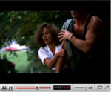
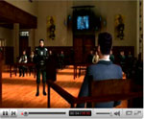
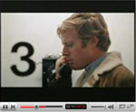

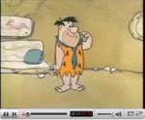
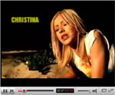
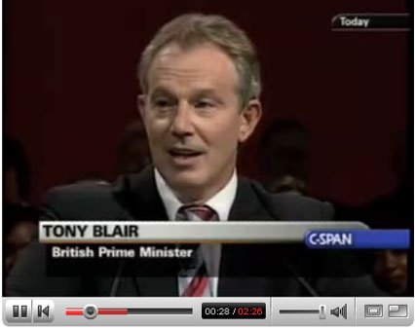
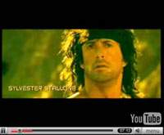
Fig. 11 ‘Blair vs The Clash’ Hits: 473,850 Fave: 293
Fig. 12 ‘A Few good G-Men’ Hits: 18202 Fave: 230

Fig. 16 ‘Stroke of Genius’ Hits: 6705 Fave: 98

Undoubtedly, other subgenres of video recut will emerge as the art form produces new artists and innovators in the field. At present, video recuts are a thriving source of new creativity and entertainment.
Fig. 17 ‘Arnie vs Sly’ Hits: 66000 Fave: 600
5 of 9

4 Design of Web Application: Total Recut

Total Recut is a video sharing web application with built in social networking facilities aimed at the online video remix community. The site has been developed using a MySQL database, PHPMyAdmin, Dreamweaver 8 and the Interakt Kollection. An innovative Flash based navigational interface was also developed using Flash 8 which requires that the user does not use the mouse click to access various sections of the site. The site also uses embedding technology from YouTube, Google Video and the Internet Archive. A regularly updated blog has been developed to collect relevant technology news and cultural memes. The site is fully searchable and scaleable. Each section can be added to or updated by Total Recut members to encourage a collaborative environment. A simplified mobile web version has been developed for the Opera Mini Browser on the Nokia platform that gives users access to text based information from the galleries, blog and contests sections of the site as well as the ability to check comments that have been made to their videos. In addition, a number of video recuts and tutorials have been created and added to the Total Recut collection.

  - Total Recut Website – Information Architecture
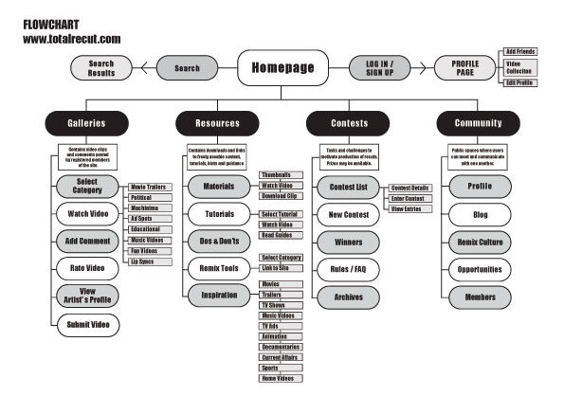

Fig. 18
Total Recut Information Architecture

  - Design Considerations

A number of design options were developed before deciding upon the superhero comic book style theme. Profiles developed for users of the Total Recut website suggested the comic book theme would be likely to resonate with many of them. The colour scheme of an overall black background with white text on red for navigational headings was chosen for its legible immediacy and striking, bold effect. The metaphorical imagery used in the Flash interface was chosen to reflect a video editing and film-making background e.g. an Oscar for the Contest section. The individual images were chosen from stock imagery for their colourful and visual impact. The font used for headings is ‘Adventure’, which reinforces the comic book style. The branding was developed as a remixed parody logo based on elements of the YouTube identity. It was felt that a guide was necessary to inform newcomers to the site as to what was on offer. To meet this need, a branded character was developed under the working title of Ragaman. Anagrams were the first known examples of remix culture and so, Ragaman is an anagram of the word ‘anagram.’ The character is a Frankenstein-like creation, composed of different body parts from well known superheroes of the film and comic book worlds. The navigation of the site was designed to be innovative and somewhat experimental, as it employs a ‘don’t click’ methodology. Users navigate the various sections solely by rolling the mouse over buttons without clicking. Half of the site employs this Flash based interface and the other half retrieves and displays content from a MySQL database using PHP. A balance was negotiated between the Flash elements of the site and the unpredictable database driven elements through repeated testing and adjustment.
6 of 9
  - Total Recut Website – Screenshots

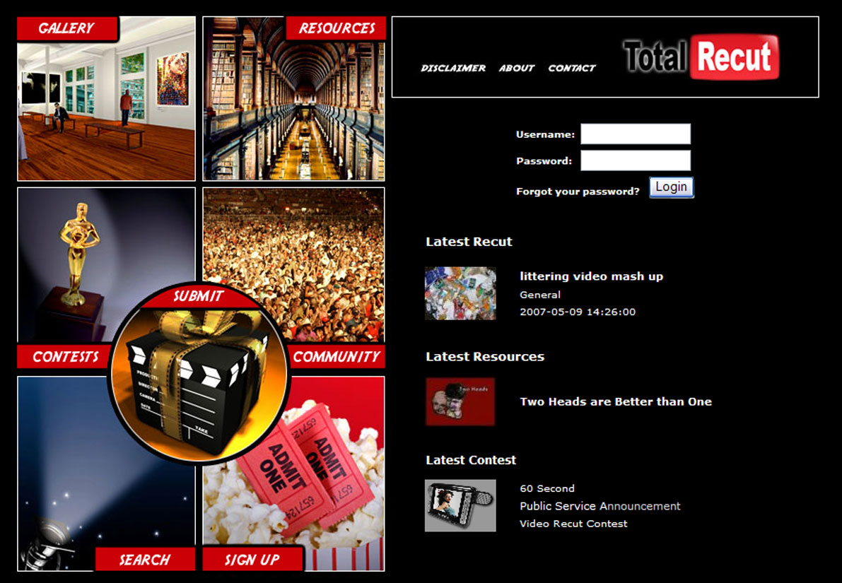

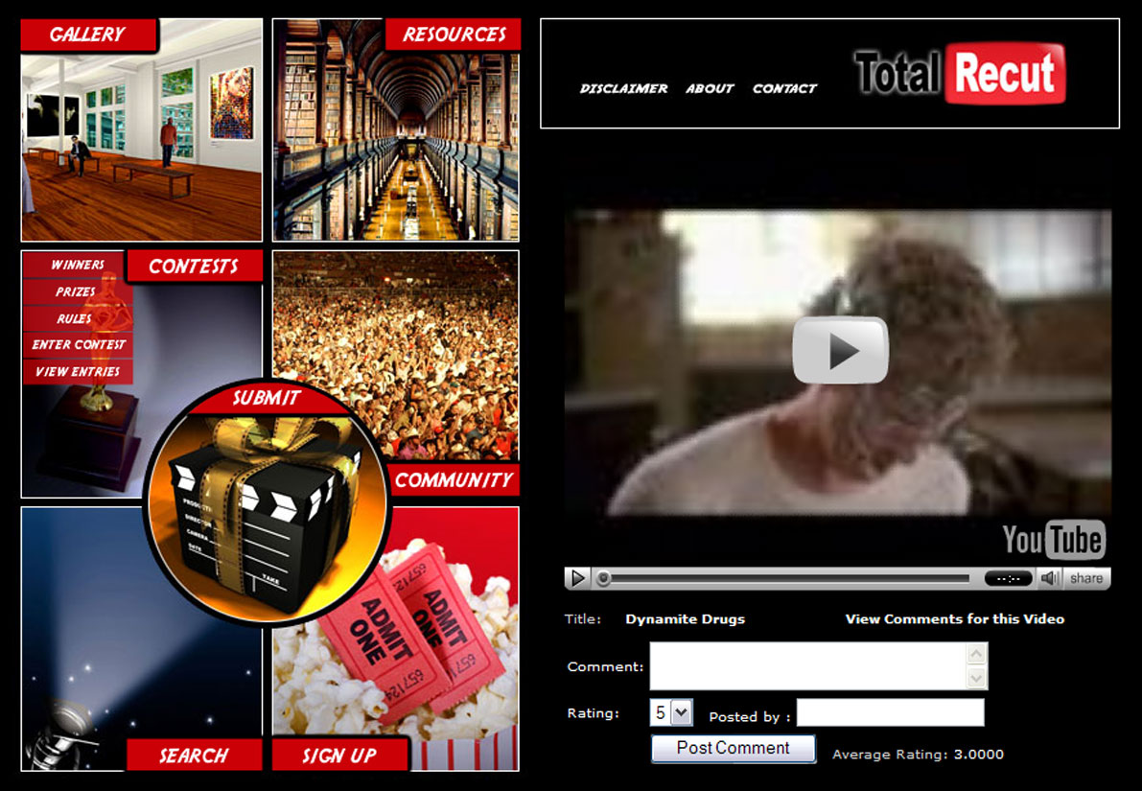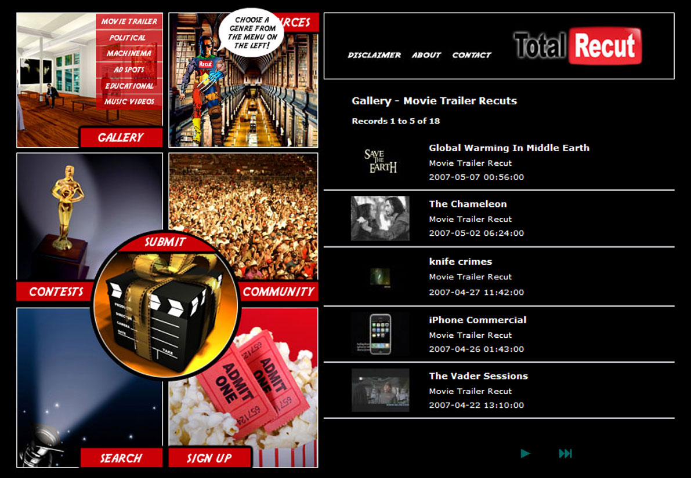

Fig. 19 - Homepage
Displays Latest Video Recut, Resource & Blog Entry
Fig. 20 - Total Recut Logo
Subverted Logo draws inspiration from YouTube

Fig. 21 - View Video Page
Users can watch, share, rate & comment on videos
Fig. 22 - Gallery
Ordered lists from the Total Recut video collection

4.4 Website Statistics

Total Recut is live at www.totalrecut.com. The site is optimised for search engine placement and ranks in the top 10 results under searches of ‘total recut’ and ‘video recut.’ To date, the site contains over 100 recuts in the gallery section, over 50 videos in the materials section, five tutorials in the education section, 20 entries in the Remix Tools section, 20 blog entries, 4 contests, and 45 registered members.

One contest has been run and judged successfully. Undergraduate Design students from the University of Ulster were asked to produce a 60 second public service announcement. 25 students entered and the three best recut creators were awarded prizes at their end of year show.

7 of 9
5 Market Testing and Evaluation

  - Media Attention

In an effort to test the market for political video recuts, two pieces were created and uploaded to YouTube and Total Recut to coincide with the Irish General elections in May 2007. Bertie Ahern was made to appear before the judging panel of the Dragon’s Den, while his opponent, Enda Kenny faced up to Simon Cowell and the judges on American Idol. Within 2 weeks, both clips had featured on numerous online blogs, most of the Irish daily and weekly newspapers, several radio stations including 2FM, 98FM and TodayFM, TV3 News and thousands of Bebo profile pages. To date, they have been watched almost 150,000 times on YouTube alone, which suggests a strong national interest in video recuts. Seven other video recuts were created for this project in various styles including Movie Trailer Recut, Music Video Mash-Up and Animated Lip Sync Recut.

  - Video Recuts Produced for Total Recut
Bertie Ahern Dragons Den
Hits: 30,783
Rating: 4/5
Favourited: 80 times
Fig. 23
The Chameleon
Hits: 1,406
Rating: 5/5
Favourited: 4 times
Fig. 25

Dynamite Drugs
Hits: 714
Rating: 3/5
Favourited: 3 times
Fig. 26

Enda Kenny American Idol
Hits: 95,032
Rating: 4/5
Favourited: 209 times
Fig. 24

Johnson & Johnson Red X
Hits: 112
Rating: 3/5
Favourited: 0 times
Fig. 27

Benny XVI Reforms Church
Hits: 608
Rating: 2/5
Favourited: 1 time
Fig. 28

Staunton’s Magnificence
Hits: 5260
Rating: 4/5
Favourited: 19 times
Fig. 29

U2 vs Hello Goodbye
Hits: 880
Rating: 4/5
Favourited: 9 times
Fig. 30

  - Business Models

Total Recut currently hosts Google Adsense and intends to adopt affiliate advertising from the likes of Amazon and AllPosters.com. Premium content will be sold in conjunction with access to free material. The tutorials section will be expanded into a Remix University, where students may partake in grades of difficulty ranging from 1 to 8. Each grade will have an accompanying exam that must be passed before progressing to the next grade. Grades 1 and 2 will be free but after that, a small fee will be charged to receive lessons for the particular grade and to take the relevant exam. Hopefully, this will help to improve the overall quality level of work produced and generate income for the site. A second, larger scale contest is planned for late 2007, which will be aimed at Universities in Ireland and the UK. Future contests will allow people to pay a small fee to enter and be in with a chance of winning the accumulated jackpot, or they can enter for free without the possibility of winning the prize, while still receiving comments and ratings for their work.

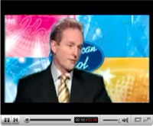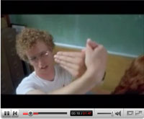

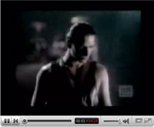

8 of 9
6 Conclusions and Future Trends

“Creativity and innovation always builds on the past. The past always tries to control the creativity that builds upon it. Free societies enable the future by limiting this power of the past. Ours is less and less a free society.”

6.1 Intellectual Property vs Freedom of Expression Rights

We are living in a time of significant change for creators and consumers of media content. On one hand, those who have amassed unfathomable wealth from being in complete control of content production and distribution want to hold onto that control. On the other, technology has enabled all of us to become content producers and distributors and millions of people are embracing this new found ability to express themselves as never before. Protecting Intellectual Property rights comes head to head with protecting Freedom of Expression rights.

Both sides are correct, in different ways, but the current situation is imbalanced in favour of copyright owners. The law with regard to copyright is outdated and inadequate to protect the rights of creative content producers on the Internet. There must be reforms. As well as being consumers, we are now participants of our culture. We want to interact with content on our own terms, remixing it and sharing it online. When large media companies say that we cannot do this, they are infringing on our basic human right to freedom of expression. Content creators want to be fairly compensated for work they have produced. When people upload copyrighted videos in their entirety to the web without permission, copyrights are being infringed.

Clearly, a new balance needs to be created and defined. Remixing content for non-commercial purposes is not an infringement of copyright, despite what the media companies would have us believe. It does not prevent or reduce the copyright owners’ potential to earn fair compensation for their work. If anything, it is a form of free promotion and may lead to increased sales of the original content.

6.2 Total Recut Mission

Total Recut has been established to ease the transition between the old and the new. The old model of monopolistic top down media company domination is giving way to democratic bottom up grass-roots individual creativity. Friction is to be expected. Total Recut gives individual remix artists a platform from which to showcase their work and also affords copyright owners with the same opportunities by encouraging them to allow their work to be remixed. Beginners can learn everything they need to know about remixing, while the more advanced can test their skills in a variety of competitions. All of this is done with a view to protecting the rights of content creators to be fairly compensated for their work while ensuring that the rights of users to express themselves freely, including sampling fairly from copyrighted work, is also protected.

  - The Future

The new digital landscape is far superior to the mass media scenario in every way. It encourages sharing and creativity at every level, empowers individuals, offers potentially unlimited choice, compensates those who create genuinely high quality, compelling work and is not fooled by over-hyped marketing and promotion. In this new era, an increasing number of people will be able to carve a living from their creative pursuits without the need to sign their rights away to a middleman. Increasing amounts of content will become available as raw materials for remix artists, as copyright owners begin to reap the benefits of freeing their work.

Although the Remix Revolution is unstoppable, those with power and money would do everything they can to try to prevent it. It is up to us, as empowered individuals of the 21st Century, not to accept their proposals of third party domination and complete control over our content. They want a permission culture. We will give them a free culture.
9 of 9
Bibliography

Books

ANDERSON, Chris. The Long Tail: How Endless Choice is Creating Unlimited Demand.
London: Random House Business Books, 2006. USA: Hyperion, 2006.

APPIGNANOSI, Richard and GARRATT, Chris. Introducing Postmodernism. UK: Icon Books, 1999

BAUDRILLARD, Jean. Fatal Strategies. London: Pluto, 1999

BAUDRILLARD, Jean. Simulacra and Simulation. USA: University of Michigan Press, 1994

FISHMAN, Stephen. The Public Domain. USA: Delta Printing Solutions, 2006

FEATHERSTONE, Mike. Consumer Culture & Postmodernism. London: Sage, 1991

FISHER, William, F. Promises to Keep: Technology, Law and the Future of Entertainment.
Stanford, California: Stanford University Press, 2004

FISHMAN, Stephen. The Public Domain: How to Find & Use Copyright Free Writings, Music, Art & More.
USA: Delta Printing Solutions, 2006.

GALE, Matthew. Dada and Surrealism. London: Phaidon Press, 1997

HARRISON, Sylvia. Pop Art & the Origins of Postmodernism. UK: Cambridge University Press, 2001

HARVEY, David. The Condition of Postmodernity. Oxford: Basil Blackwell, 1989

JENKINS, Henry. Convergence Culture: Where Old and New Media Collide. USA: NYU Press, 2006

KEEN, Andrew. The Cult of the Amateur: How Today’s Internet is Killing Our Culture.
London: Nicholas Brealey Publishing, 2007.

KIRSNER, Scott. The Future of Web Video. California: Lulu.com, 2007

KUSEK, David & LEONARD, Gerd. The Future of Music: Manifesto for the Digital Music Revolution.
Boston, Massachusetts: Berklee Press, 2005

LASICA, J.D. Darknet: Hollywood’s War Against the Digital Generation. New Jersey: John Wiley & Sons, 2005

LESSIG, Lawrence. Code and Other Laws of Cyberspace. USA: Basic Books, 1999

LESSIG, Lawrence. Free Culture: The Nature & Future of Creativity. USA: Penguin Books, 2005

LESSIG, Lawrence. The Future of Ideas. New York: Vintage Books, 2002

LITMAN, Jessica. Digital Copyright. USA: Prometheus Books, 2006.

MCLEOD, Kembrew. Freedom of Expression: Overzealous Copyright Bozos and Other Enemies of Creativity.
USA: Doubleday, 2005.

NEGROPONTE, Nicholas. Being Digital. Great Britain: Hodder & Stoughton, 1995

ROBBINS, Jennifer. Web Design in a Nutshell. 3rd Edition. USA: O’Reilly Media, 2006.

SANDLER, Irving Art of the Postmodern Era. New York: Westview, 1996

THIERER, Adam. Copy Fights: The Future of Intellectual Property in the Information Age.
Washington: Cato Institute, 2002

VAIDHYANATHAN, Siva. Copyrights & Copywrongs: The Rise of I.P. & How it Threatens Creativity
USA: NYU Press, 2003.

Articles

ANDERSON, Chris. “People Power.” Wired Magazine. July 2006. p.132.

ARBER, Jason. “Creative Common Sense.” Computer Arts Magazine. Nov.2006. p.22.

CONSTITUTION, American. “Article 1, Section 8, Clause 8.” The American Constitution. Sept.1787.
(http://www.usconstitution.net/xconst_A1Sec8.html)

CROMELIN, Richard and HEALEY, John. “When Copyright Law Meets the ‘Mash-Up.’” Los Angeles Times. Mar.2004 (http://www.boycott-riaa.com/article/11117)

EUROPE, Council of. “European Convention on Human Rights.” Article 10: Freedom of Expression. Nov, 1950
(http://www.hri.org/docs/ECHR50.html#C.Art10)

FRANCIS, Kerry. “The Faculty of Video Mash-Up.” The Pirate University. April 2007.
(http://www.pirate-university.org/wiki/index.php?n=Faculties.VideoMash-UpMixing)

GAINES, Jane. “Early Cinema, Heyday of Copying.” Indiana University. 2003
(http://www.indiana.edu/~bookworm/ip-toc.html)

GROOM, Jim. “Video Mashups: Using 1970’s Softcore to Learn About Vietnam?” Bava Tuesdays. July, 2007.
(http://bavatuesdays.com/video-mashups-using-1970s-softcore-to-learn-about-vietnam/)

HEINS, Marjorie. “Thrashing the Copyright Balance.” Free Expression Project. Oct. 2002.
(www.fepproject.org)

NATIONS, United. “Universal Declaration of Human Rights.” Article 19: Freedom of Expression. Dec, 1948
(http://www.un.org/Overview/rights.html)

JOHNS, Adrian. “Intellectual Property and the Nature of Science.” Indiana University. 2003
(http://www.indiana.edu/~bookworm/ip-toc.html)

JONES, Steve. “Reality© and Virtual Reality©: When Virtual and Real Worlds Collide.” Indiana University. 2003
(http://www.indiana.edu/~bookworm/ip-toc.html)

KEHAULINI GOO, Sara. “Art and Marketing All Mashed Up.” Washington Post. Aug.2006. (www.washingtonpost.com)

LESSIG, Lawrence. “Make Way for Copyright Chaos.” New York Times. March, 2007.
(http://www.nytimes.com/2007/03/18/opinion/)

PERRY BARLOW, John. “The Economy of Ideas.” Wired Magazine. Mar.1994.
(http://www.wired.com/wired/archive/2.03/economy.ideas_pr.html)

RODMAN, Gilbert B. & VANDERDONCKT, Cheyanne. “Music for Nothing or, I Want My MP3:
The Regulation and Recirculation of Affect.” Indiana University. 2003
(http://www.indiana.edu/~bookworm/ip-toc.html)

SCHAFER, Ian. “Consumer-Manipulated Content.” The Clickz Network, Jan 2007.
(http://www.clickz.com/3624493)

SCHONFELD, Erick. “In Defence of the (Mash-up) Artist.” Blogs.business2.com. June 2006.
(http://blogs.business2.com/business2blog/2006/week23/index.html)

STRIPHAS, Ted and MCLEOD, Kembrew. “The Politics of Intellectual Properties.” Indiana University. 2003.
(http://www.indiana.edu/~bookworm/ip-toc.html)

WARK, McKenzie. “Information Wants to be Free (But is Everywhere in Chains.)” Indiana University. 2003
(http://www.indiana.edu/~bookworm/ip-toc.html)

WAYNE, Wax. “Mash Politik.” Blogspot.com. July 2005.
(http://wayneandwax.blogspot.com)

WIRTEN, Eva Hemmung. “Out of Sight and Out of Mind: On the Cultural Hegemony of Intellectual Property.”
Indiana University. 2003 (http://www.indiana.edu/~bookworm/ip-toc.html)

ZIMMERMANN, Patricia R. “Just Say No: Negativland's No Business.” Indiana University. 2003
(http://www.indiana.edu/~bookworm/ip-toc.html)

Websites

http://www.boingboing.net/
(Blog for all things innovative or unusual)

www.copyright.gov / www.copyrightservice.co.uk / www.cai.ie
(Copyright law USA, UK and Ireland)

www.creativecommons.org
(Organisation promoting free culture)

www.darknet.com
(Organisation promoting free culture)

http://www.eff.org/
(Electronic Frontire Foundation – Fighting to balance Freedom of Expression Rights with copyrights)

http://hypem.com/
(Flash Based Music Blog Aggregator)

http://www.imdb.com/
(Internet Movie Database)

http://joox.net/
(DivX Quality Video Links Site)

http://keepvid.com/
(Video Conversion Utility)

http://www.lessig.org/
(Blog and Website of Lawrence Lessig)

http://mashable.com/
(Blog for mash-up related websites and news)

www.mashculture.nl
(website for all things to do with mash-up culture)

www.mashuptown.com
(online resource for mash-up content)

http://www.mulley.net/
(Technology Blog)

http://radar.oreilly.com/
(Blog site for technology news)

http://www.readwriteweb.com/
(Blog for the latest online startups)

http://www.socialmedia.biz/
(Blog for the Remix Revolution)

http://www.techcrunch.com/
(Blog for the latest in technological advances and related business)

http://themoviepreviewcritic.com/
(Movie Trailer Review Site)
http://www.wikipedia.org/
(Online collaborative encyclopaedia)

http://www.wired.com/
(Blog and Website for Wired Magazine discussing the latest trends in technology)

www.youtube.com
(The industry’s leading video sharing website)

DVDs / Video Clips

ALPER, Loreta. Captive Audience: Advertising Invades the Classroom. USA, 2003.

CHOMSKY, Noam. Rebel without a Pause USA: Redcanoe Prouductions, 2003

CHOMSKY, Noam. Imperial Grand Strategy. USA: AK Press, 2005

FENG SUN, Chyng. Mickey Mouse Monopoly. USA, 2001

FOUNDATION, Media Education. Behind the Scenes: Hollywood Goes Hypercommercial. USA, 2000

JHALLY, Sut. Advertising and the End of the World. USA, 1997

JOHNSEN, Andreas. Good Copy. Bad Copy. Denmark: Rosforth, 2007.

KLEIN, Naoimi. No Logo: Brands, Gloablization and Resistance. USA, 2003

LESSIG, Lawerence. Creative Commons. USA: Lessig.org, 2002-2007 (www.lessig.org)

MCLEOD, Kembrew. Copyright Criminals. USA, 2007

MCLEOD, Kembrew. Freedom of Expression: Resistance and Repression in the Age of Intellectual Property.
USA, 2007.

MCLEOD, Kembrew. Money for Nothing: Behind the Business of Pop Music. USA, 2001

SHAUN, Twila. Alternative Freedom. USA: Project Free Zarathustra, 2006

Magazines

COMPUTER ARTS (industry leader for the design arts)

WIRED (industry leader for trends in technology)

Figures

Fig.1: J.D. Lasica - (http://www.jdlasica.com/aboutjd.html)

Fig.2: Lawrence Lessig - (http://www.lessig.org/bio/short/)

Fig.3: Henry Jenkins - (http://www.henryjenkins.org/)

Fig.4: Kembrew McLeod - (http://kembrew.com/academics/)

Fig.5: Antonio Da Silva, AMDS Films - (http://spiritsnodeal.canalblog.com/)

Fig.6: Terminator vs Robocop, AMDS Films - (http://spiritsnodeal.canalblog.com/)

Fig.7: Bush – Sunday Bloody Sunday, DJ RX - (http://www.thepartyparty.com)

Fig.8: 10 Things I Hate About Commandments - (http://www.myspace.com/smackyproductions)

Fig.9: Titanic 2: The Surface, Robert Blankenheim - (http://www.robertblankenheim.com/)

Fig.10: Dirty Dancing Recut - (http://www.youtube.com/watch?v=zJSmZzJdHp8)

Fig.11: Blair vs The Clash, DJ RX - (http://www.youtube.com/watch?v=nupdcGwIG-g)

Fig.12: A Few Good G-Men, Nailbiter - (http://www.youtube.com/watch?v=qA3OgWspGAc)

Fig.13: Apple iPhone Commercial - (http://www.youtube.com/watch?v=XA6dLFrAFlI)

Fig.14: Creativity Always Builds on the Past - (http://www.youtube.com/watch?v=O0xQplM4Tn0)

Fig.15: Raging Fred - (http://www.youtube.com/watch?v=U502uzVmcAE)

Fig.16: A Stroke of Genius - (http://www.youtube.com/watch?v=Y3A46ek5Iy4)

Fig.17: Arnie vs Sly - (http://spiritsnodeal.canalblog.com/)

Fig.18: Total Recut Information Architecture

Fig.19: Total Recut Homepage – (http://www.totalrecut.com)

Fig.20: Total Recut Logo

Fig.21: Total Recut View Video Page – (http://www.totalrecut.com/totalrecutgallerydetail.php)

Fig.22: Total Recut Gallery Page – (http://www.totalrecut.com/totalrecutgalleryall.php)

Fig.23: Bertie Ahern on Dragons Den - (http://www.youtube.com/user/ragaman7)

Fig.24: Enda Kenny on American Idol - (http://www.youtube.com/user/ragaman7)

Fig.25: The Chameleon - (http://www.youtube.com/user/ragaman7)

Fig.26: Dynamite Drugs - (http://www.youtube.com/user/ragaman7)

Fig.27: Johnson & Johnson Sue Red Cross - (http://www.youtube.com/user/ragaman7)

Fig.28: Pope Benny XVI Reforms Catholic Church - (http://www.youtube.com/user/ragaman7)

Fig.29: Steve Staunton’s Magnificent Madness - (http://www.youtube.com/user/ragaman7)

Fig. 30 U2 vs Hello Goodbye – (http://www.youtube.com/user/ragaman7)

FISHMAN, Stephen. The Public Domain. USA: Delta Printing Solutions, 2006. Pg 4
JENKINS, Henry. Convergence Culture. USA: New York University Press, 2006. Pg 258
LASICA, J.D. Darknet: Hollywood’s War Against the Digital Generation. USA: John Wiley, 2005. Pg 266
LESSIG, Lawrence. Free Culture. London: Penguin Books, 2005. Pg 271
The Trailer Mash [ www.thetrailermash.com ]
Mash-Up Charts [ www.mashup-charts.com ]
Video Recut statistics derived from YouTube.com as of August 2007
LESSIG, Lawrence. Free Culture: Keynote Speech at OSCON 2002. USA, 2002 (http://www.oreillynet.com/pub/a/policy/2002/08/15/lessig.html)

